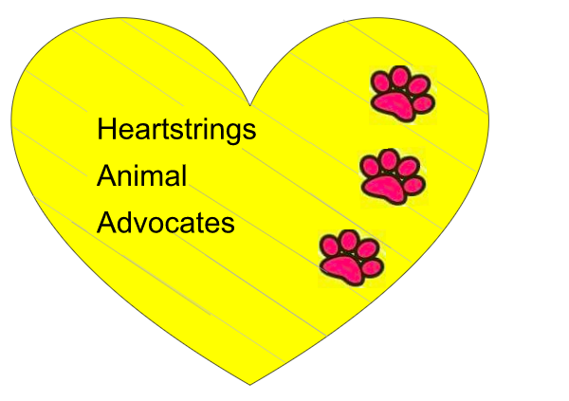
Heartstrings Volunteer Application

Name:______________________________ Phone Number:__________________

Facebook Profile Name: _______________________________

Please list any experience you might have with animals:_________________________
______________________________________________________________________

Please indicate which items you would like to volunteer with:

______ Bi-Weekly Kennel cleaning (1st & 3rd Saturday or Sunday of the month @ small outdoor facility) (Duties include; washing dog houses; cleaning kennels; walking dogs; bathing dogs)

______ Special events (Fundraisers)

______ Adoption Events (handle and walk/hold dogs as well as prompt to person in charge to get proper paperwork filled out for dogs)

_____ Distributing Flyers for special events (taking flyers to local businesses to display for upcoming fundraisers)

_____ Helping coordinate and facilitate special events

